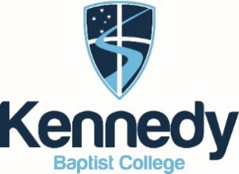
ASSESSMENT OUTLINE- 2020 (Updated- 08/05)

CHEMISTRY ATAR Y11

UNITS 1 AND 2

Assessment type  (from syllabus) | Assessment  type weighting | Assessment  task  weighting | When | Assessment task
Practical and  Investigation | 25% | 9% | T3: Week 6 | Task 9: Post laboratory test 2 on- Reaction rate and concentration/ temperature, Intermolecular forces in alcohols
 |  | 8% | T1: Week 6 | Task 3: Determining the Waters of Crystallisation of an unknown salt.
 |  | 8% | T3: Week 7 | Task 10: Using chromatography to analyse the strength of intermolecular forces in various colours of ink.
Extended response | 10% | 5% | T1: Week 3 | Task 1: Extended response 1 - Discovery of the atom.
 |  | 5% | T3: Week 1 | Task 7: Extended response 2- Energy and CO₂ output for fossil fuels and biofuels
Test | 15% | 2% | T1: Week 4 | Task 2: Properties and Structure of Atoms
 |  | 2.5% | T2: Week 4 | Task 4: Properties and Structure of Materials: Organic Chemistry
 |  | 3% | T2: Week 5 | Task 5: Chemical Reactions: Reactants, Products and Energy Change
 |  | 2% | T3: Week 2 | Task 8: Rates of Chemical Reactions
 |  | 2.5% | T3: Week 9 | Task 11: Intermolecular Forces and Gases
 |  | 3% | T4: Week 3 | Task 12: Aqueous Solutions and Acidity
Examination | 50% | 15% | T2: Week 7-8 | Task 6: Semester 1 examination – Covers Unit 1 content
 |  | 35% | T4: Week 5-6 | Task 13: Semester 2 examination – Covers Unit 1 and 2 content
Total | 100% | 100%

